**FINAL Assessment - Plastics and Composites Engineering**

**Questionnaire (40 points)**

## What are the differences and similarities between the injection molding and the extrusion processes? (2/40)

Similarities:

Both processing techniques require a polymer melt. Melting occurs through the various sections of the screw. The polymer is feed, melted and moved towards the die as the screw rotates, meaning that sections of the screw shall be design for different purposes.

Differences:

In extrusion is a continuous process, where the polymer melt is fetched from the tip off the die. As the polymer melt leaves the extruder, it is stretched/manipulated and cools down into the desired shape such as fibers and blown films.

The injection process is not continuous as a mold is required to shape the polymer product. Contrary to extrusion, in injection molding, the screw not only rotates but also moves as a “syringe” or piston. First the melt is moved towards the exit die through the screw rotation and then the piston motion injects the melt into the mold.

## What are the differences between the free radical and the condensation polymerization? Show an example of each. (2/40)

Free radical polymerization is a type of addition polymerization where no by-products are generated (“no loss”). Whereas in condensation polymerization, by-products (such as water) are generated when merging monomers.

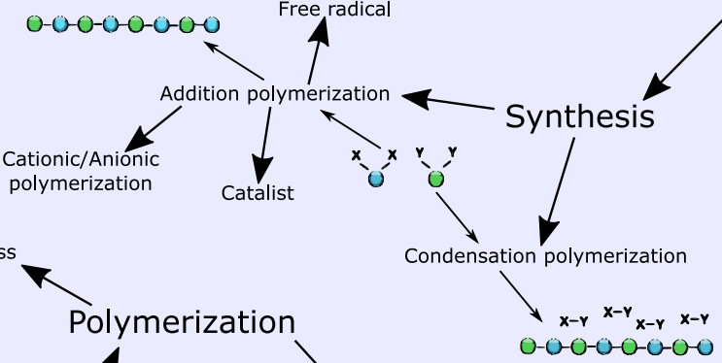

*Figure 1 – Polymerization: screenshot of my infography*

## Make a drawing of the melt flow indexer, depict the flow phenomenon along the barrel, the die and the extrudate leaving the die and explain why this test is commonly used in the industry. (4/40)

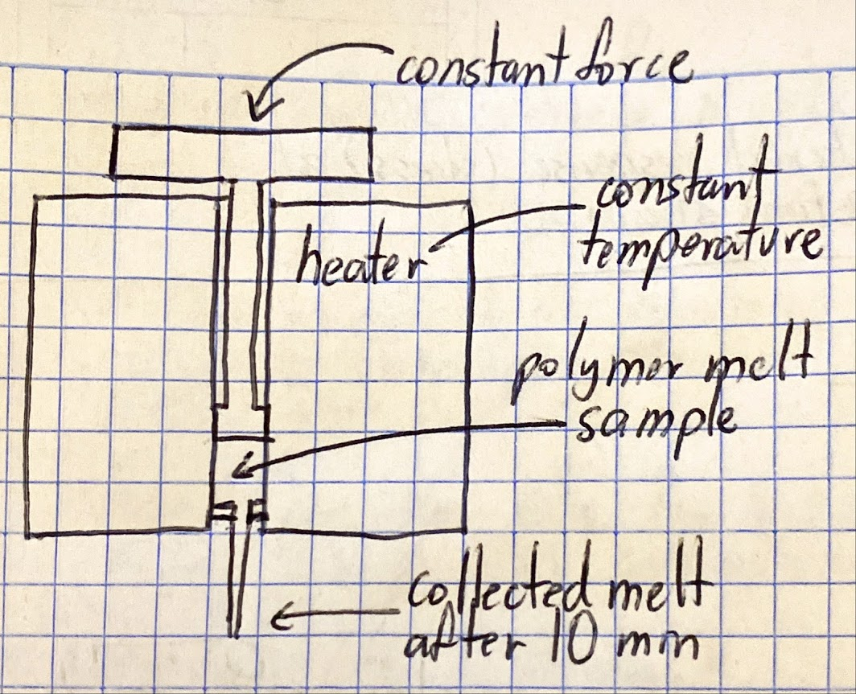

The melt flow index or MFI measures how easily a thermoplastic melt can flow. In this measurement the polymer is pushed through a die with pre-stablished dimensions at a constant temperature for 10 minutes. The MFI is used in industry to compare variations of the same polymer describing a relation to the molecular weight. (low MFI has a higher molecular weight than a high MFI of the same polymer)

## What is the origin of die swell and what would you do to avoid it, or at least to reduce it? (2/40)

Die swell is a product defect in polymer extrusion. It happens when the product is wider/bigger than the die dimensions. It is the result of the release of stresses in the extruded product leaving the die. As the polymer “remembers” its original shape and tries to return to it. One solution would be to modify the MWD to amend the compliance modulus. In other words, a thinner distribution is prone to a creep faster and a slower recovery.

## What is the most relevant rheological property in free wall deformation polymer process and what type of test would you do to measure it? (2/40)

The stress. As in free wall deformation, the material is exposed to a constant stress. Therefore the most appropriate test is the compliance modulus J, which measures changes in strain (deformation) against a constant stress.

## You want to save money for the company you are working on and you got the following information from three suppliers (identified as A andB), beside their MFIs are very similar (2/40)

|  |  |  |  |
| --- | --- | --- | --- |
| Resin | Mw | Mn | Cost ($) |
| Original | 2,500,000 | 500,000 | X |
| A | 2,000,000 | 400,000 | 0.90X |
| B | 3,000,000 | 600,000 | 0.92X |

### a. Is that information good enough for you to decide to buy one of them? **No**

**Justify your answer.**

First, it is known that the increase of MFI relates to a broader MWD and decreases the dynamic viscosity. However, the MFI is only one data point of the whole viscosity vs. shear rate curve, which does not provide enough information to compare different polymers.

On the other hand, and the Mw and Mn partially describe the MWD. The Mz is also required to calculate the PDI and estimate the broadness of the curve. As the broadness also describes the slope of the viscosity curve, the creep behavior, and rate of recovery.

### b. What would be the resin with the lowest zero shear viscosity?

The one with the higher molecular weight, in this case resin B

## You are talking to your advisor about the course and since his discipline is not in rheology, he asks you about why tan d changes with frequency. What would you tell him? (2/40)

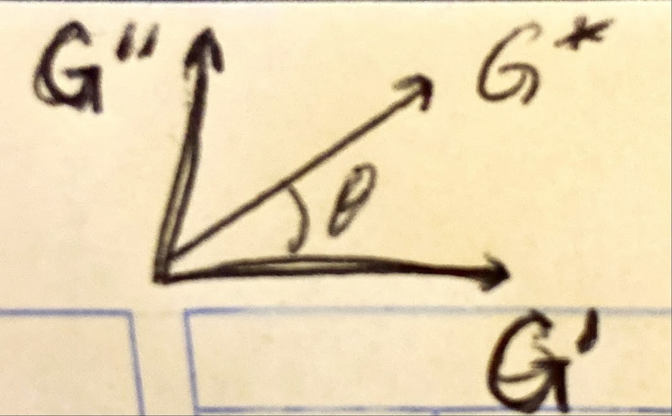

Since Tan d = G’’ / G’, delta is the angle of the movement of the rheometer geometry (within a oscillatory test). A lower delta angle means a higher oscillation frequency, at higher frequencies the viscosity (G’) increases and the elasticity (G’’) decreases.

## How would you mathematically model the metering section of an extruder, to get the pressure increase as the polymer goes forward? (4/40)

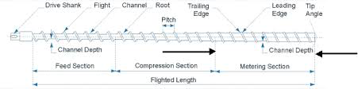

The modelling would be based on Navier-Stokes equation with cylindrical coordinates.

## You are working as a consultant and a company needs your expertise to solve a problem: they have a high frequency device to melt pellets and every time they do it, they have different results. What could it be your explanation? (2/40)

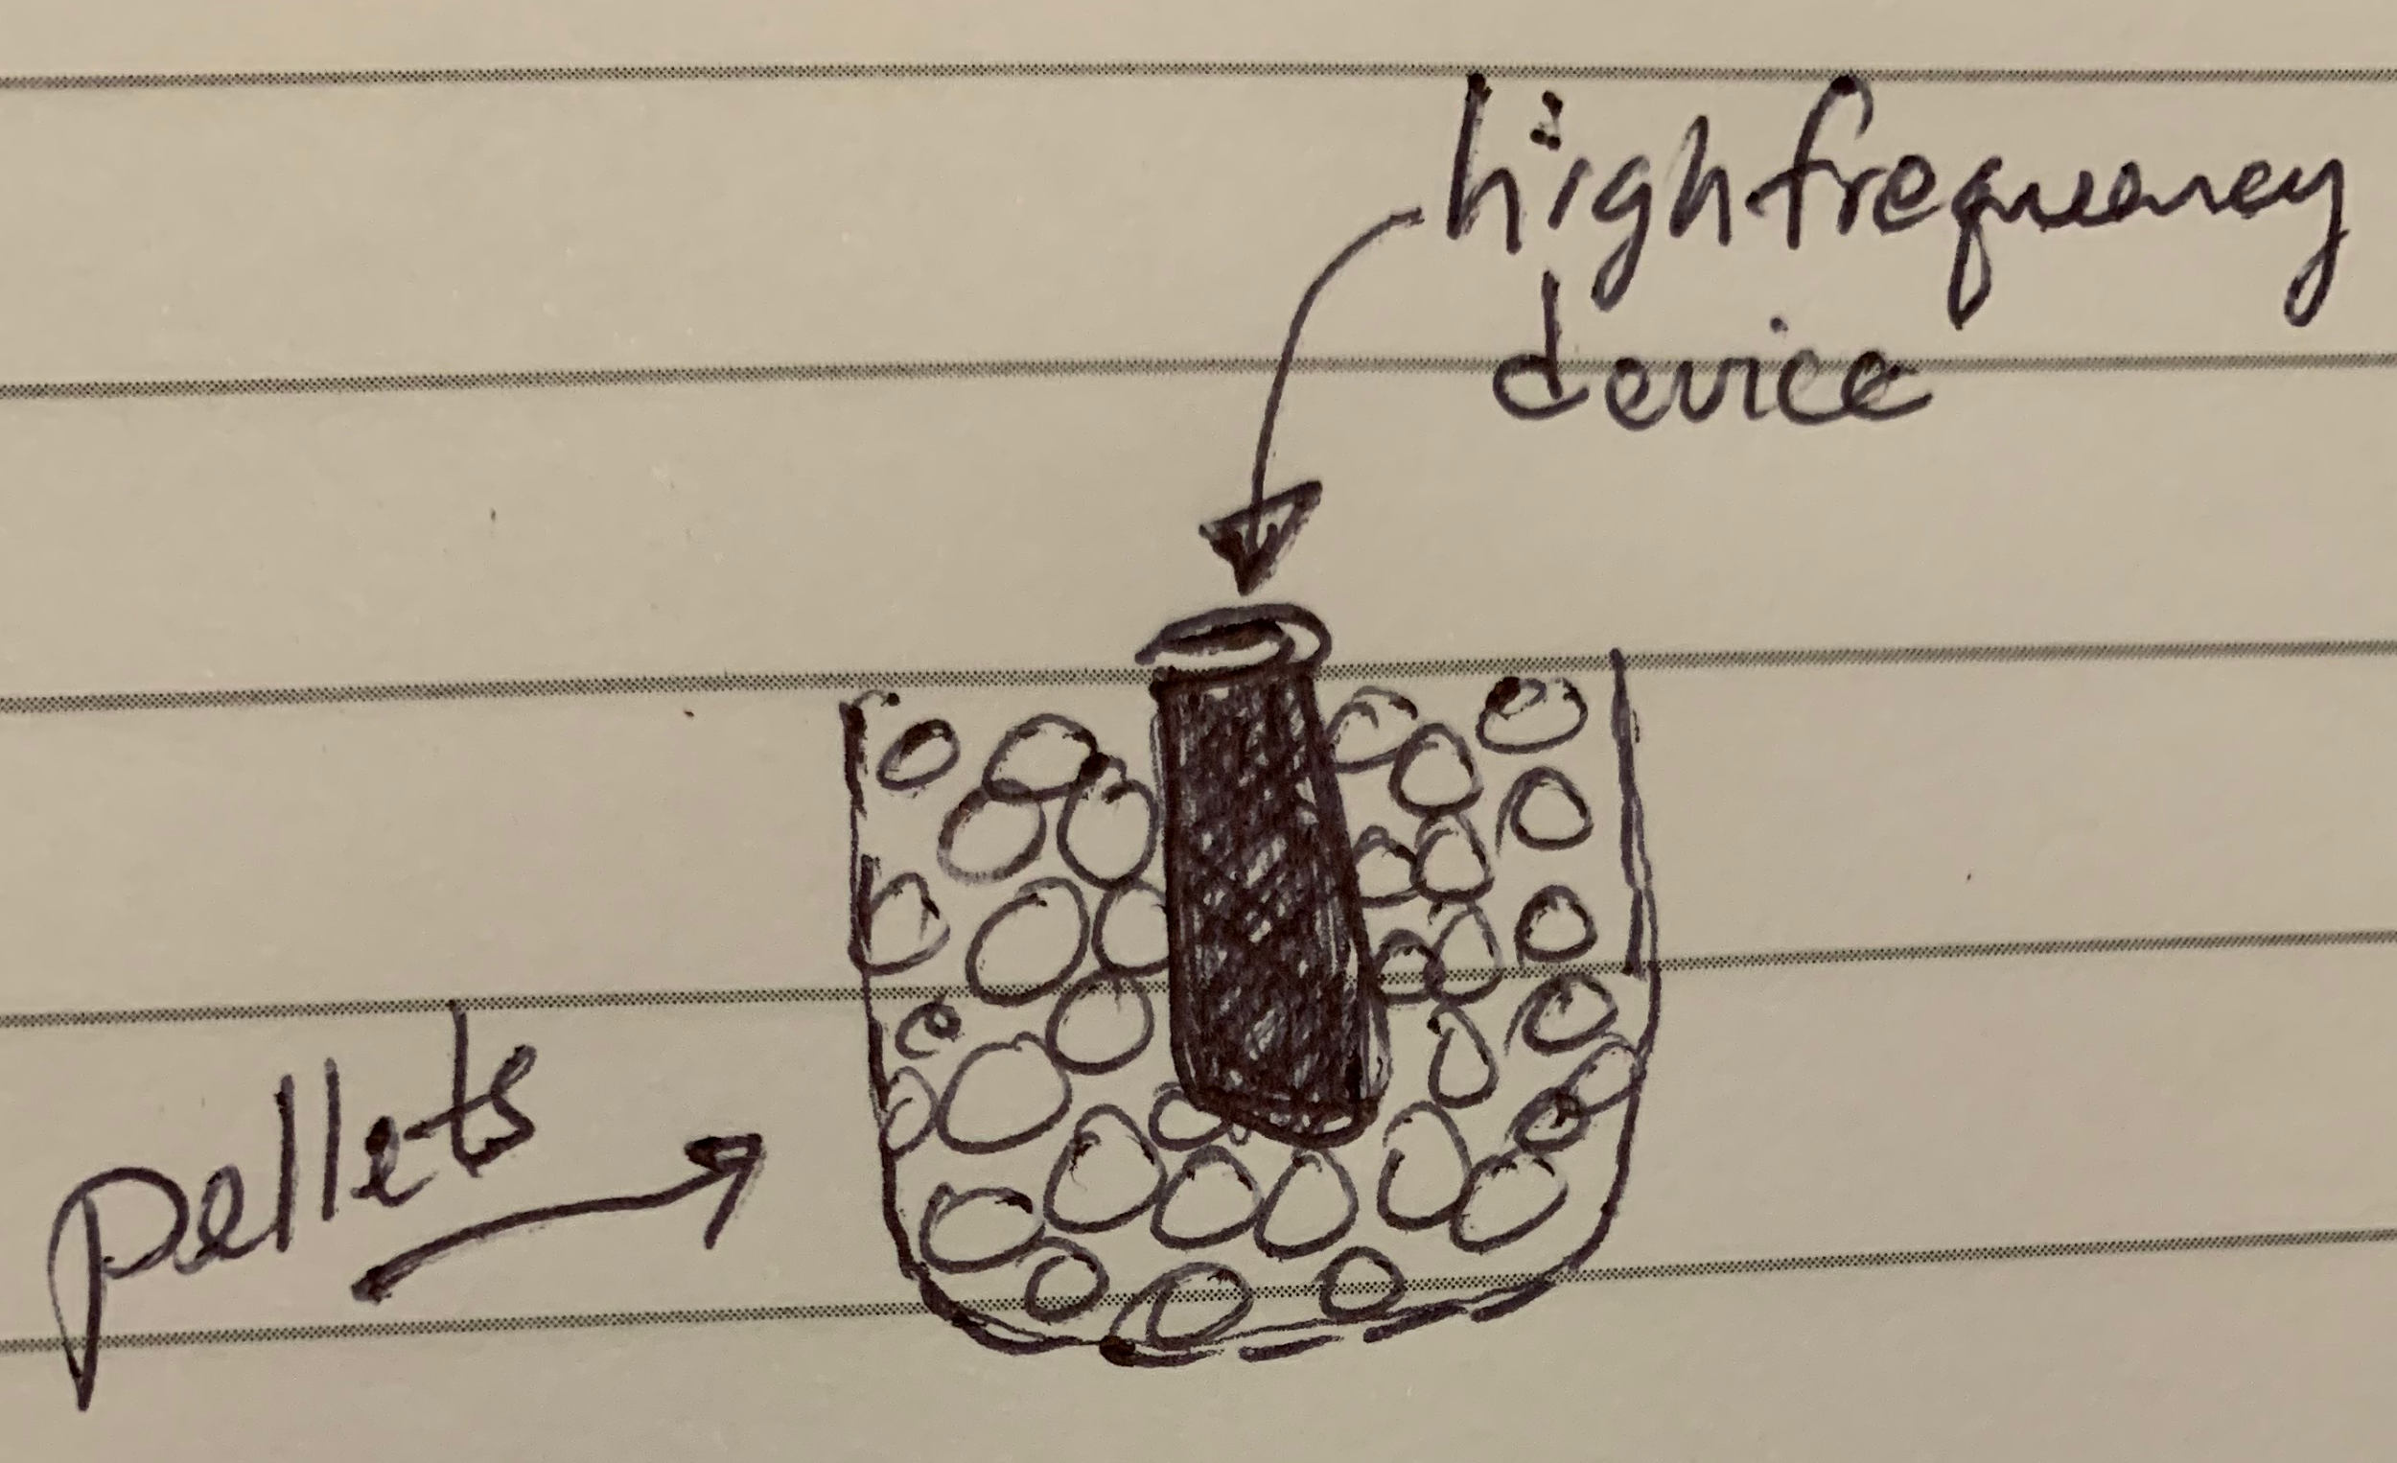

## There is a gel that has a lot of carboxylic acids and they want to increase their elasticity adding Calcium Acetate (Ca++Ac2). (4/40)

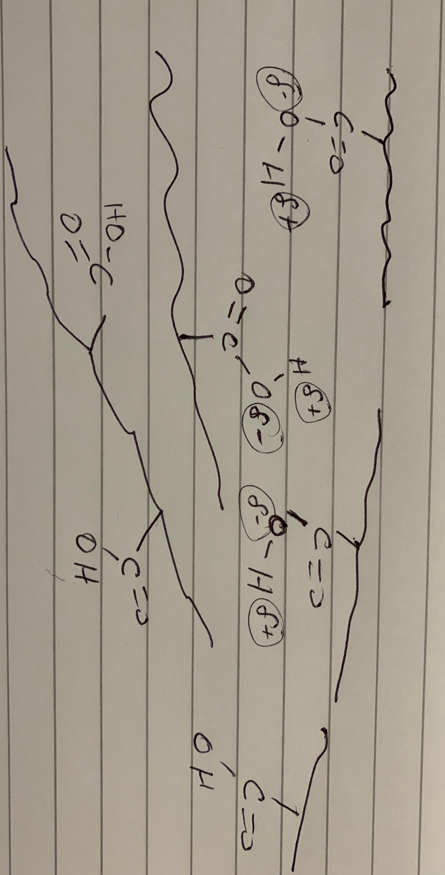

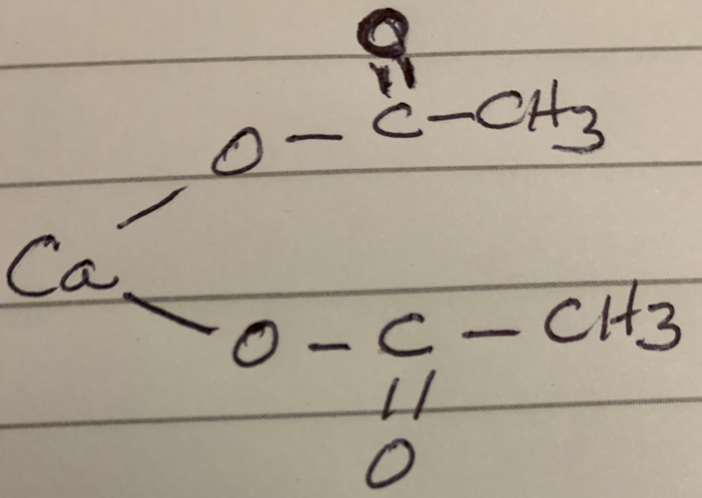

### a. Would that be possible?

Yes, as they form ionic crosslink bonds. The carboxylic acid opens the possibility of having a salt like sodium in the alginic acid. If the sodium hydroxide comes in with alginic acid, a salt will be produced. Then the sodium salt dissolves in the water. Meaning that the carboxylic acid becomes negatively charged. The addition of the acid positively changes the polymeric chain and therefore linked to the carboxylic acid.

### b. What type of rheological tests would you do?

A constant shear rate test to get the viscosity modulus. The zero-shear viscosity of the original and amended material could be used to describe the increase in crosslink density.

## What are the differences between the relaxation modulus and the creep compliance modulus and how could you model them using mechanical analogs? (4/40)

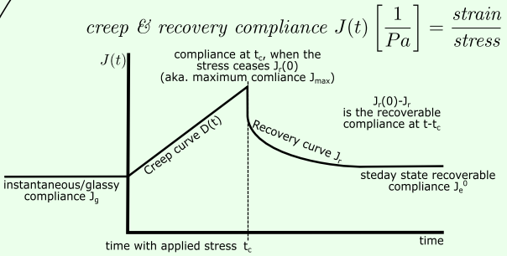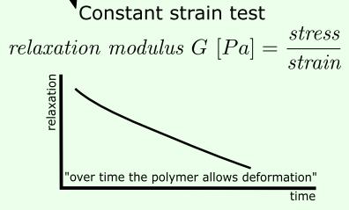

The relaxation modulus is given by a constant strain test, whereas the creep compliance modulus is given by a constant stress test. The creep modulus could be modelled with a weight acting on a viscoelastic material, and the relaxation modulus could be modelled by deforming a spring or rubber band.

## Superposition Principles: (4/40)

### a. What is the importance of the TTS principle

TTS is used to describe the viscoelastic behaviour of polymers at short and long observation times. The reference temperature can be selected and superposed into a master curve with temperature dependent (vertical and horizontal) shift factors. Higher temperatures are measured to “accelerate” the deformation.

### b. What is the Boltzman Superposition Principle

The creep is a function of the loading/stress history. Each stress step contributes to the total/final deformation. Meaning that the total deformation is the sum of each stress contribution

### c. Can they be combined?

Yes, as the TTS can be used to create a master curve of the compliance modulus at different temperatures.

## You are interviewing a person, who brags he took a course in Polymer Engineering, and you asked him about how he could describe a stress tensor and he mentions that “ is equivalent to 3 vectors and could be described by three directions and their magnitudes. (2/40)

* 1. Do you agree with his statement? Explain

Yes, as the stress at a point in a fluid needs nine components (3 vectors x 3 directions) to be completely specified. As each component of the stress is defined by the direction in which it acts and on the surface it is acting.

## Explain step by step how the master curve was obtained and what would you do to get the tensile modulus at 106 seconds at 70oC {4/40pts}

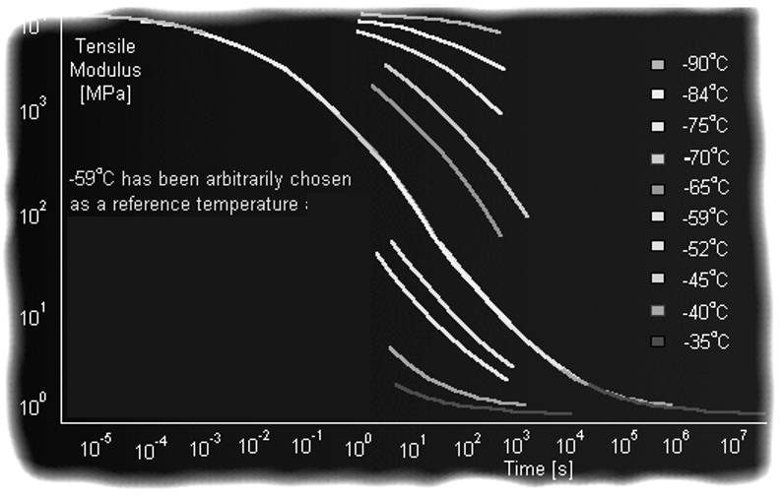

1. Manually calculate the horizontal and vertical shift factors for each curve to match the reference temperature curve at -59C
2. plot the vertical and horizontal shift factors against (1/T - 1/T_ref) and do a linear regression. The slope of the regression line are the activation energies
3. use the activation energies and the WLF equation to compute the shit factors for the new reference temperature of 70C
4. use the newly calculated shift factors to shift the master curve to the 70C temperature
5. look at the 106 sec and calculate the tensile modulus at that time.